Project Title:
Face Mask Detection Using Deep Learning



Student names:
Layan AlQahtani 202200722
Leen AlQahtani 202200686
Lana Alsharif 202200612
Razan AlHarbi 202200428
Course: Computer Vision
Submission Date: 12/07/2025

Table of Contents
1.Abstract 3
2. Introduction & Background 3
2.1 Context & Motivation 3
2.2 Problem Statement 3
2.3 Literature Review 3
3. Theory & Methodology 4
3.1 Theoretical Foundation 4
3.2 Proposed Method 4
4. Implementation & Dataset 4
4.1 Dataset Description 4
4.2 Data Preparation 5
4.3 Model Training 7
4.4 Evaluation Metrics 7
4.5 Inference 7
5. Results & Analysis 8
5.1 Quantitative Results 8
5.2 Visual Results 8
5.3 Critical Discussion 8
6. Conclusion & Future Work 8
References 10

1.Abstract
This project implements an automated face mask detection system using the YOLOv5 deep learning architecture. The objective is to accurately classify individuals into three categories: with mask, without mask, and mask worn incorrectly. The Kaggle Face Mask Detection dataset was preprocessed, converted to YOLO-compliant format, and split into training, validation, and test sets. A YOLOv5s model was trained for 30 epochs, producing evaluation metrics including precision, recall, mAP, loss curves, and confusion matrices. Results demonstrate strong performance for “with mask” and “without mask” categories, with reasonable performance for “mask worn incorrectly.” The system shows practical viability for real-time monitoring applications in public safety environments.

2. Introduction & Background

2.1 Context & Motivation
The COVID-19 pandemic highlighted the importance of face mask compliance as a public health measure. Manual monitoring of mask usage in public spaces is inefficient and error-prone. Automated detection systems powered by computer vision can improve safety by identifying violations in real time.

2.2 Problem Statement
The problem addressed is the automatic detection of mask-wearing status in images using a deep learning model capable of identifying three distinct conditions:
- With Mask
- Without Mask
- Mask Worn Incorrectly

2.3 Literature Review
Early approaches to face detection relied on classical machine learning algorithms such as Haar Cascades or SVM classifiers. With advancements in deep learning, convolutional neural networks (CNNs) have become dominant, especially for real-time detection tasks. YOLO (“You Only Look Once”) is widely used due to its speed and accuracy. Prior studies using YOLOv3 and YOLOv4 achieved good results but required larger computational resources. YOLOv5, a lightweight and optimized model, offers improved efficiency, making it suitable for practical deployment.

3. Theory & Methodology

3.1 Theoretical Foundation
YOLOv5 formulates object detection as a single end-to-end regression problem. Instead of separating region proposals and classification, YOLO predicts bounding boxes and class probabilities in one forward pass. The model uses convolutional layers to extract spatial features and anchors to estimate bounding box dimensions.
Key concepts include:
- Bounding Box Regression
- Non-Maximum Suppression (NMS)
- Cross-Entropy Classification Loss
- Intersection-over-Union (IoU)

3.2 Proposed Method
The methodology includes:
- Dataset collection and annotation conversion
- Preprocessing and dataset structuring
- Training YOLOv5s for 30 epochs
- Evaluating model using standard YOLO metrics
- Running inference on test images
A flowchart summarizing the workflow:
Dataset → Annotation Conversion → Train/Val/Test Split → YOLO Training → Evaluation → Inference

4. Implementation & Dataset

4.1 Dataset Description
The dataset used in this project is the Face Mask Detection dataset from Kaggle.
It contains 853 images annotated in PASCAL VOC XML format, with three classes:
- with_mask
- without_mask
- mask_worn_incorrectly
Each XML file contains bounding box coordinates and class labels for every face in the image. The raw dataset was downloaded and organized into separate folders:
annotations/ → XML label files
images/ → original images
prepare_dataset.py → preprocessing script

4.2 Data Preparation
YOLOv5 requires standardized folder structure and label format. To prepare the dataset, a preprocessing script (prepare_dataset.py) was created.
Below is a high-level explanation of what the script does (no code needed in report):
Steps performed by prepare_dataset.py
- Read Each XML File
  - Extract image dimensions.
  - Extract bounding boxes (xmin, ymin, xmax, ymax).
  - Extract class names for each object.
- Convert Bounding Boxes to YOLO Format
YOLO expects normalized coordinates:
  - x_center = (xmin + xmax) / 2 / image_width
  - y_center = (ymin + ymax) / 2 / image_height
  - width = (xmax - xmin) / image_width
  - height = (ymax - ymin) / image_height
- Map Class Names to Numeric IDs
with_mask → 0
without_mask → 1
mask_worn_incorrectly → 2
- Save YOLO Label Files
  - One .txt file per image in labels_all/.
- Split Into Train/Validation/Test
  - 80% training images
  - 10% validation images
  - 10% test images
- Copy Files Into YOLOv5 Format
datasets/mask/
images/train/
images/val/
images/test/
labels/train/
labels/val/
labels/test/
This ensures full compatibility with YOLOv5 training requirements.

To train YOLOv5, the dataset’s XML annotations (Pascal VOC format) needed to be converted into YOLO format.
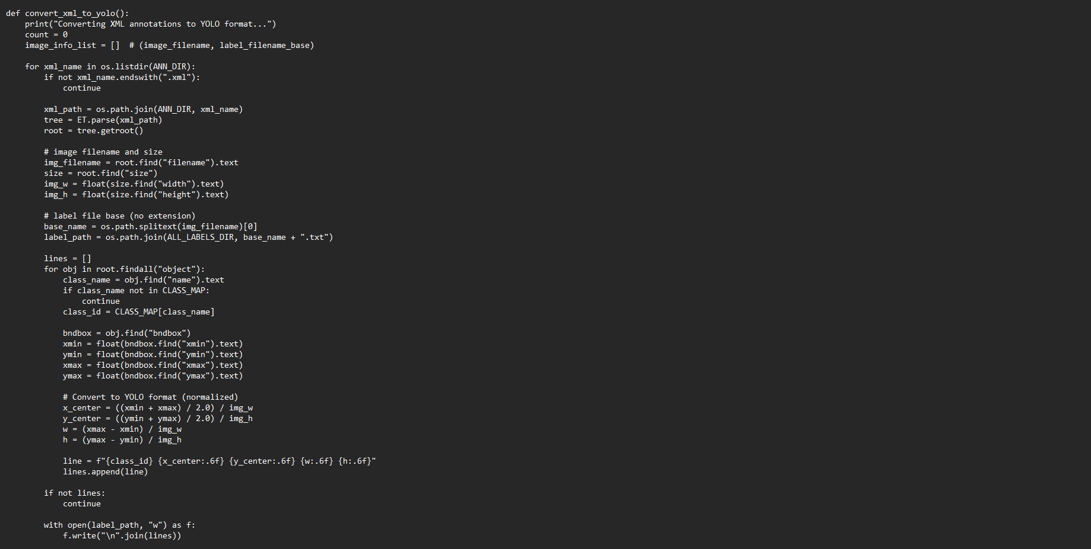
This shows a Python function that was used to convert bounding boxes into YOLO-normalized coordinates (x_center, y_center, width, height)

4.3 Model Training
Training was performed using YOLOv5s with this command:
python train.py --img 640 --batch 16 --epochs 30 --data data/mask.yaml --weights yolov5s.pt --name mask_detector
YOLOv5 automatically saved:
- Loss curves
- Precision/Recall curves
- F1 score curves
- Confusion matrices
- Batch visualizations
- Model weights (best.pt, last.pt)

4.4 Evaluation Metrics
YOLOv5 evaluation includes:
Metric | Description
Precision (P) | Correct positive detections
Recall (R) | Ability to detect all relevant instances
mAP@50 | Mean Average Precision at IoU 0.50
mAP@50–95 | Stricter precision across multiple thresholds

The validation results indicated strong performance for the “with mask” and “without mask” classes, with lower but acceptable performance for “mask worn incorrectly” due to fewer examples.

4.5 Inference
Inference was performed using:
python detect.py --weights runs/train/mask_detector/weights/best.pt --source path/to/test/images
YOLOv5 generated labeled predictions stored in:
runs/detect/exp/

5. Results & Analysis

5.1 Quantitative Results
Summary of key metrics:
Class | Precision | Recall | mAP@50 | mAP@50–95
With Mask | 0.964 | 0.953 | 0.953 | 0.628
Without Mask | 0.617 | 0.889 | 0.882 | 0.526
Mask Incorrect | 0.208 | 0.235 | 0.258 | 0.184
Overall mAP@50: 0.698

5.2 Visual Results
1. Confusion Matrix
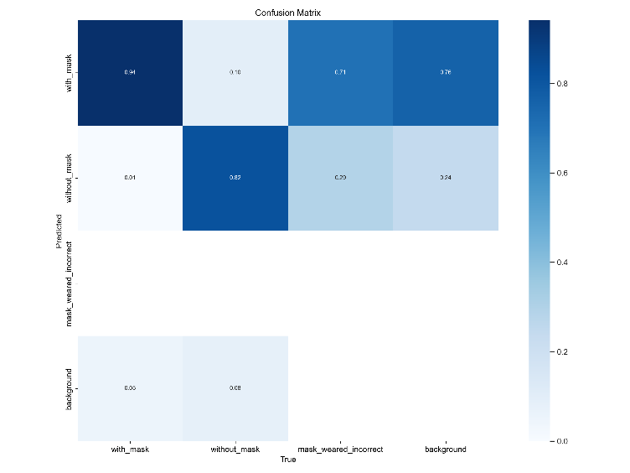
Figure 1. Confusion matrix showing classification performance across the three mask categories.

2. F1 Curve
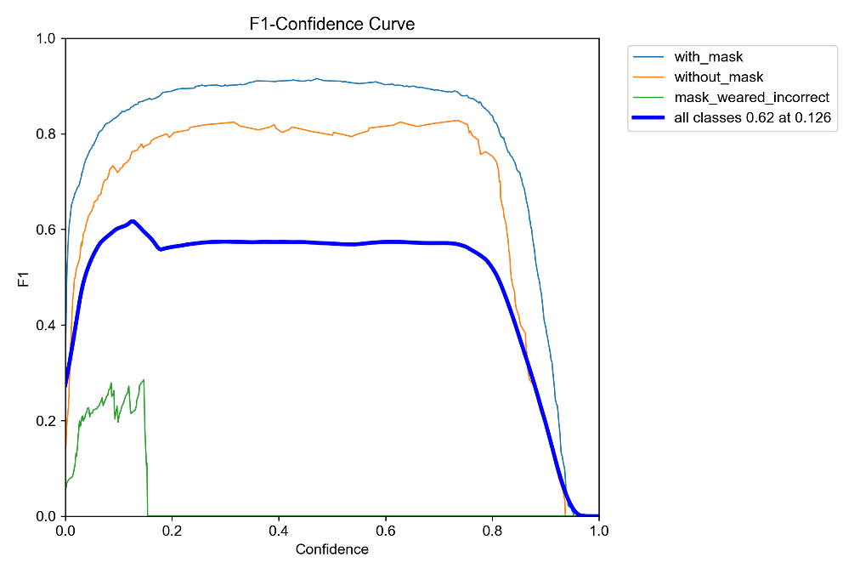
Figure 2. F1-score curve showing changes in the harmonic mean of precision and recall during training
3.Labels Distribution
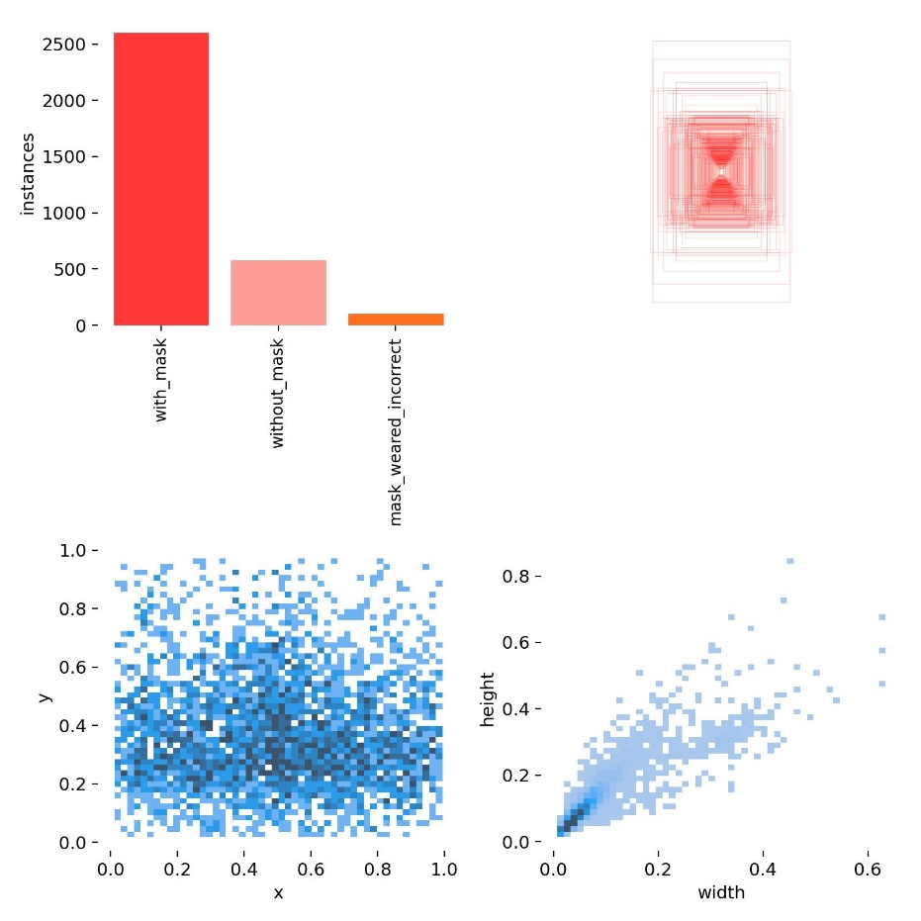
Figure 3. Distribution of labels in the dataset, showing the frequency of each mask class.

- Labels Distribution
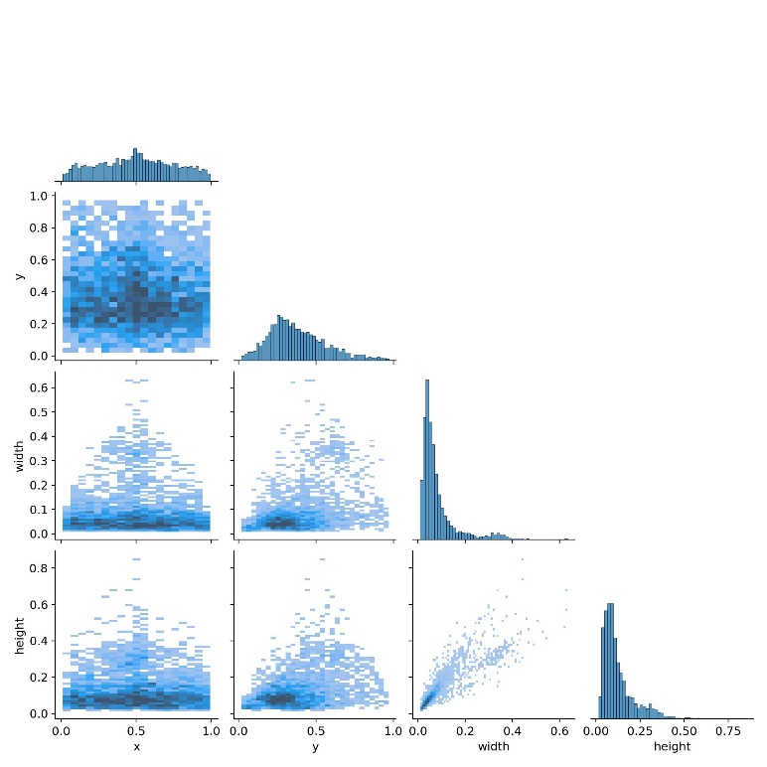
Figure 4. Label correlogram visualizing the relationships and co-occurrence patterns within the dataset.
- PR Curve
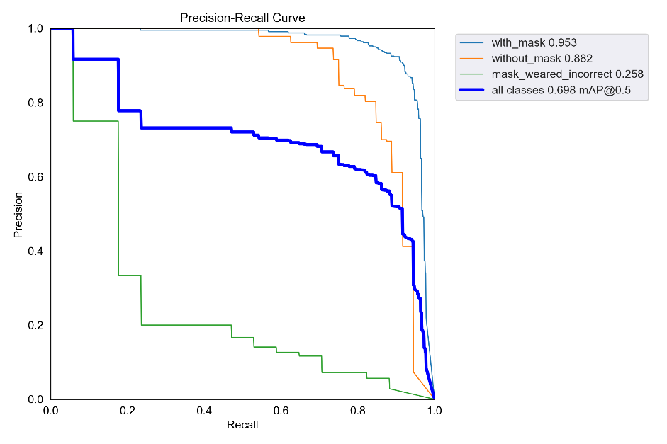
Figure 5. Precision–Recall curve illustrating the model’s precision–recall tradeoff across different confidence thresholds.

- Training Batch Preview
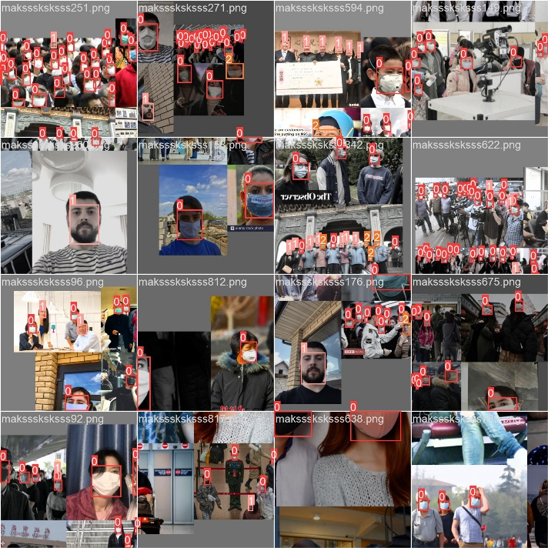
Figure 6. Sample training batch showing annotated images used during model training.
- Sample Prediction
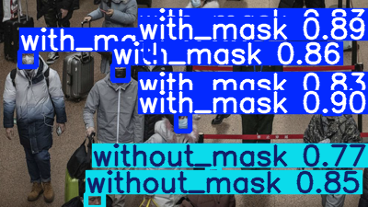
Figure 7. Mixed prediction sample showing detection of multiple mask categories simultaneously.

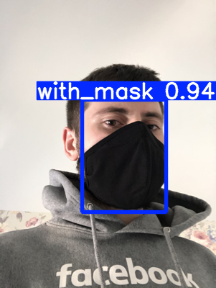
Figure 8. Sample model prediction correctly detecting individuals wearing a mask.
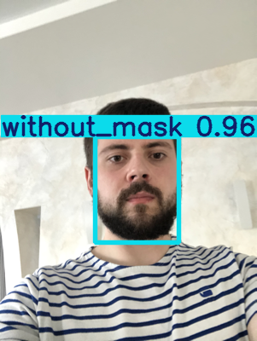
Figure 9. Sample model prediction accurately identifying individuals without a mask.

5.3 Critical Discussion
- The model performs best for the “with mask” class due to abundant examples.
- The “mask worn incorrectly” class had the lowest performance because of limited training samples, affecting generalization.
- Increasing dataset size or using augmentation could significantly improve performance.
- Despite CPU-only training, the model achieved good accuracy within reasonable time.

6. Conclusion & Future Work
Conclusion
This project successfully implemented a YOLOv5-based face mask detection system capable of recognizing three mask conditions. The system demonstrated strong accuracy for two out of three classes and produced reliable detection results suitable for real-world scenarios.
Future Work
- Use GPU training to reduce training time.
- Expand dataset, especially for the “mask worn incorrectly” class.
- Deploy the model in real-time applications using OpenCV or a webcam feed.
- Convert model to TensorRT / ONNX for faster inference.
- Implement tracking for monitoring video streams over time.

References
- Jocher, G. (2020). YOLOv5. GitHub repository. https://github.com/ultralytics/yolov5
- Kaggle. Face Mask Detection Dataset. https://www.kaggle.com/datasets
- Redmon, J., & Farhadi, A. (2018). YOLOv3: An incremental improvement.
- He, K., et al. (2015). Deep Residual Learning for Image Recognition. CVPR.

